SUMMARY REPORT FROM THE DATA ANALYIS ON DISTRICT’s HIGH SCHOOL PERFOMANCE ON MATH and READING

1. Out of 15 high schools and 39,710 students in total, the average scores of Math and Reading were quite comparable.



Compared to the nation-wide data [published here for](https://www.nationsreportcard.gov/reading/nation/scores/?grade=12) grade 12, these average scores were considerably higher.

1. 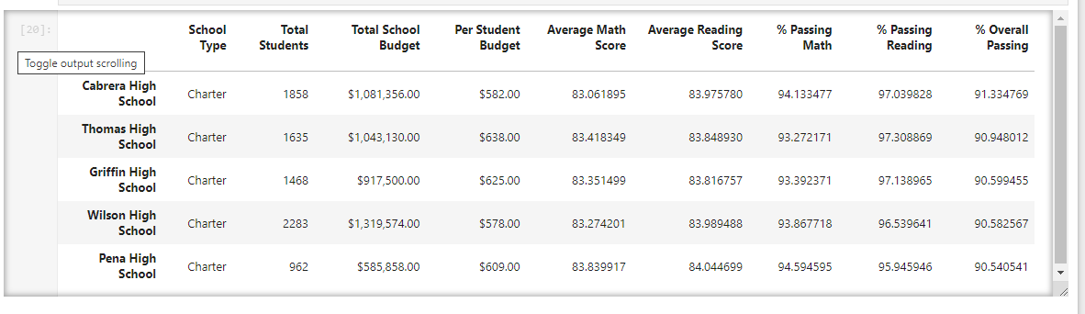Here are the top five schools by Overall Passing Percentage.

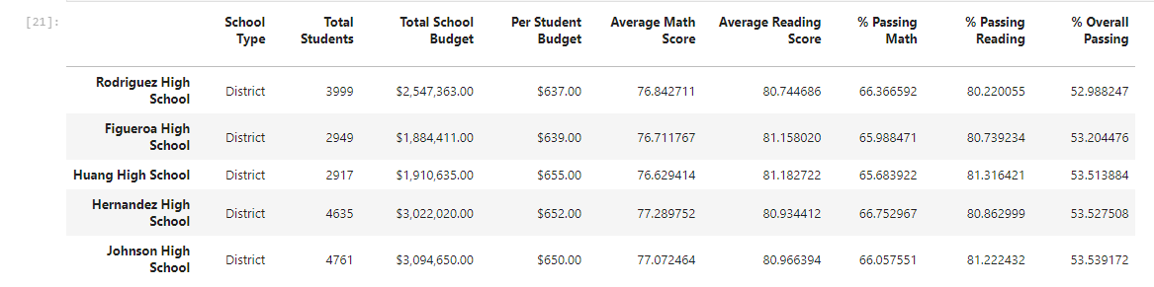Their passing percentages were significantly higher than the bottom-table schools whose passing percentages hover slightly above 50%.

1. On Math Subject respectively, the performance across different grades within the same school was quite consistent.

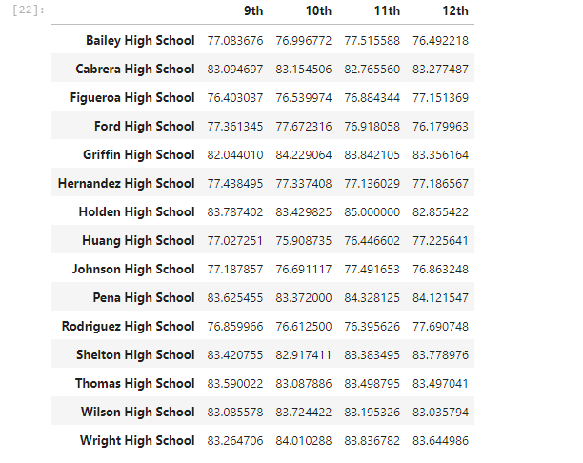

1. Same observation on the Reading Subject across different grades within the same school.

1. When analysis was completed, there was no correlation found between the spending ranges and the passing rates. Some high schools with the lowest spending ranges were actually top performers.

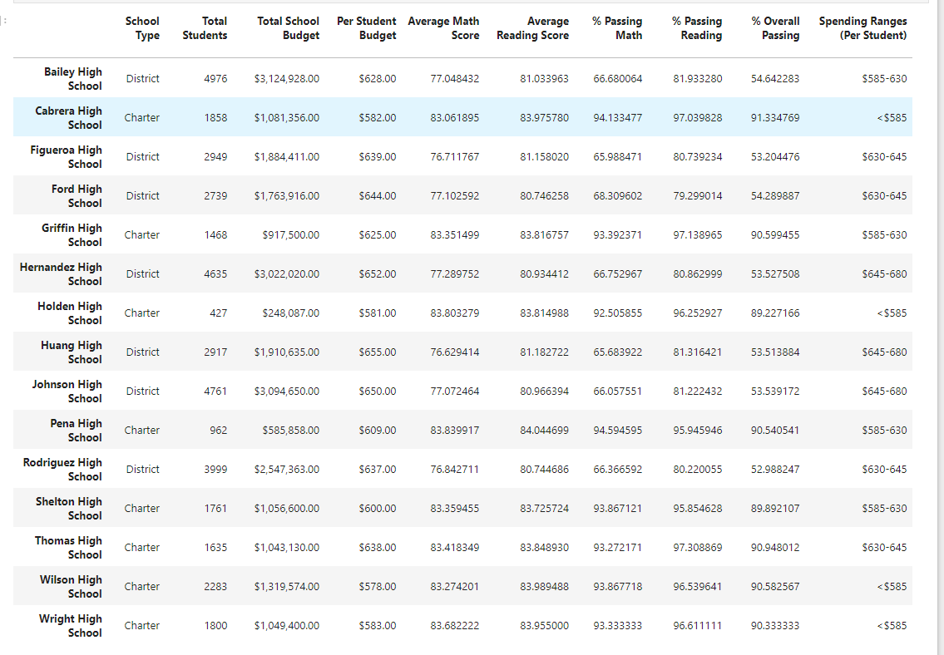

1. It is interesting to find that most of the large-sized schools except Wilson High School performed quite badly. The bottom 5 performers were all large-sized schools. Small and Medium sized schools were doing better.

1. The charter-typed schools were doing better than the district-typed schools.

